**INCOME DISTRIBUTION AND FACTOR PRICING**

**The marginal productivity theory** of distri­bution, tells us how the price of a factor of production is determined. According to this theory, the price of a factor tends to equal the value of its marginal product. For example rent is equal to the value of the marginal product (VMP) of land; wages are equal to the VMP of labour

**Assumptions of the Theory**

**1. Perfect competition in both product and factor markets:**

The theory assumes the perfect competition in both product and factor markets. It means that both the price of the product and the price of the factor (say, labour) remains unchanged.

**2. Operation of the law of diminishing returns:**

It assumes that the marginal product of a factor would diminish as additional units of the factor are employed while keeping other factors constant.

**3. Homogeneity and divisibility of the factor:**

All the units of a factor are assumed to be divisible and homogeneous. It means that a factor can be divided into small units and each unit of it will be of the same kind and of the same quality.

**4. Operation of the law of substitution:**

The theory assumes the possibility of the substitution of different factors. It means that the factors like labour, capital and others can be freely and easily substituted for one another. For example, land can be substituted by labour.

**5. Profit Maximization:**

The firm will hire factors in such a way as to maximize profits. This can be achieved by employing each factor up to that level at which the price of each is equal to the value of its marginal product.

**6. Given State of Technology**

The state of technology is assumed to be constant**.**

#### Some Key Concepts:

The theory is based on certain concepts.

**1. MPP:**

Marginal physical product of a factor. The marginal physical product (MPP) of a factor, say, labour, is the increase in the total product of the firm when additional workers are employed by it.

**2. VMP:**

The second concept is value of marginal product. If we multiply the MPP of a factor by the price of the product, we would get the value of the marginal product (VMP) of that factor.

**3. MRP:**

The third concept is marginal revenue product (MRP).It is the addition to the total revenue when more and more units of a factor are added to the fixed amount of other factors, or MRP = MPP x MR. Under perfect competition, the VMP of the factor is equal to its marginal revenue product (MRP) since MR= P.

**1.DERIVATION OF DEMAMD CURVE OF A FACTOR**

The derivation of demand curve for factor is illustrated in Fig. 32.7. Firm will hire more and more units of a factor until its marginal revenue product equals its marginal factor cost. If there is a perfect competition in the factor market, then marginal factor cost (MFC) of the factor will be equal to the market price of the factor.

[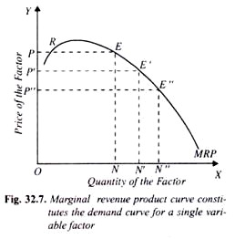](http://cdn.yourarticlelibrary.com/wp-content/uploads/2014/04/clip_image0024100.jpg)

A perfectly competitive buyer in the factor market will employ a factor of production to a point where its MRP, which is equal to VMP is equal to its market price. In doing so, he will be maximising his profits and will thus be in equilibrium position.

Thus, in Fig. 32.7, if the market price of a factor is OP, then the employer will hire or employ ON units of the factor since at ON units MRP of the factor is equal to its price OP. Thus, at mar­ket price OP, ON amount of the factor will be demanded by the producer.

If now the market price of the factor falls to OP’ the amount de­manded of the factor will rise to ON’ where marginal revenue product of the factor is equal to the new market price OP’. If the factor price further falls to OP”, the ON” quantity of the factor will be demanded by the firm. So given the market price of the factor, we can determine the quantity demanded of the factor by the firm from the marginal revenue product curve . The marginal revenue product curve of a variable factor usually first rises upward to a point and then slopes down­ward.

But it should be noted that only **the downward-sloping portion of the MRP curve forms the demand curve for that factor**. This is so because the entrepreneur cannot be in equilibrium at the rising part of the MRP curve.

For instance, with market price OP, the entrepreneur will not be in equilibrium at point R, since at R, marginal revenue product curve is cutting marginal factor cost curve (which is here same as factor price curve) from below.

The firm will be in equilibrium at point E where MRP curve is cutting the factor price curve from above and will employ or demand ON amount of the factor. So under perfect competition in the factor market, down­ward sloping part of the marginal revenue product curve of the factor is the demand curve for that factor.

If we assume that the price of the product does not change as the industry employs more of the factor and thus expands its output, **the demand curve for the factor of production of the whole competitive industry would be obtained by the horizontal summation of the MRP or VMP curves of the firms** (i.e. demand curves of the firms) in the industry.

**2. Firm’s Demand Curve for a Factor: With all Factors (inputs) Variable:**

A fall in the price of a variable factor, such as wage rate of labour generally leads to the increase in employment not only of labour but also of other factors as well, at least in the long run. Note that the two factors are said to be complementary if increase in the amount of one raises the marginal productivity of the other.

Thus, when due to the decline in wage rate the employ­ment of labour is increased, it also leads to the increase in the quantity of capital. This increase in the quantity of capital will increase the marginal productivity of labour.

So value of marginal product (VMP) curve of labour will shift to the right. When other factors such as capital, raw materials are variable, and wage rate falls, it will not only lead to the in­crease in the demand for labour but will also lead to change in the amount of other factors.

Considering that the two factors, labour and capital are complementary to each other, when there is increase in the employment of labour conse­quent to a fall in wage rate, it would bring about increase in the quantity of capital (and other factors), at least in the long run.

How the long-run demand curve of a factor is derived is shown in Figure 32.8, where to start with the VMP has been drawn with a given amount of capital equal to K1. At wage rate OW, the firm demands ON0 amount of labour (OW = VMP at ON0amount of labour).

Now, if the wage rate falls to OW’ the firm will demand labour equal to CW, provided the capi­tal stock had remained constant at K1. How­ ever the increase in the quantity demanded of labour at the lower wage rate OW would increase the marginal product of capital and therefore in the long run the firm would adjust the amount of capital.

The increase in capital to K2 in the production process causes a shift in the value of marginal product (VMP) curve of labour to the new position VMP’. With this new marginal value product curve of labour, VMP’ obtained after adjusting the amount of capital to the level K1 at the lower rate OW’ the firm will demand CW2 quantity of labour.

Thus by joining points like E and B, we obtain the firm’s demand curve EB for labour when capital is also variable and adjusted . It will be seen from the Figure 32.8 that firm’s demand curve for labour EB obtained when other factors such as capital are varied is more elastic than the VMP curves.

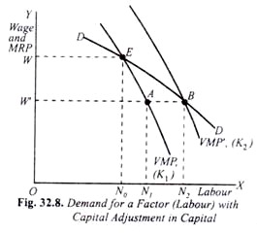

**Competitive Industry’s Demand Curve for a Factor:**

ADVERTISEMENTS:

We can obtain the competitive industry’s demand curve for labour by the horizontal summation of the VMP curve (i.e. demand curves) of the factor of all firms assuming that price of the product remains constant or unchanged.

This is however not realistic. When following the reduction in the wage rate all the firms in the industry employ more labour in the production of a commodity, the output of commodity and therefore its supply in the market increases. This would result in lowering the price of the product.

**[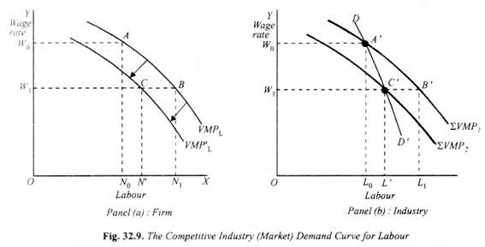](http://cdn.yourarticlelibrary.com/wp-content/uploads/2014/04/clip_image006411.jpg)**

It may be recalled that the value of marginal product (VMPL) of labour under perfect competi­tion in the product market equals marginal physical product (MPP) of labour multiplied by the price of the product (under perfect competition MRPL = VMPL = MPPL x Price of Product.

Now, following the reduction in wage rate, as more labour is employed by all the firms in the competitive indus­try output expands bringing about a fall in the price of the product. This will cause a shift in the value of marginal product curve of labour (VMPL) to the left as shown in Panel (a) of Figure 32.9 where when the price of the product falls from P0 to P1 the value of marginal product curve of labour shifts to the left to its new position VMP’L and as will be seen from panel (a) of Figure 32.9 that at the lower wage rate W1 the firm demands and employs labour ON rather than ON1 amount of labour which it would have demanded at the lower wage rate W1 if the product price had remained constant at P0.

This represents the product price effect on the demand for labour. It will be seen that when this price effect is taken into account, with the reduction in the wage rate from W0 to W1 the firm’s demand for labour increases from ON0 to ON’ and not to ON1.

Having explained how a firm’s demand for labour is affected by the change in price of the product following the reduction in the wage rate, we can now derive the market demand curve for labour of the competitive industry. This is illustrated in panel (b) of Figure 32.9. At the wage rate OW0 a competitive firm employs ON0 amount of labour by equating wage rate OW0 with the value of marginal product of labour (VMPL), price of the product equal to P0 being given. (See panel (a) in Figure 32.9).

At the wage rate OIVQ the demand for labour of the industry as a whole can be obtained by the horizontal summation of the quantity demanded of labour by the given number of firms. Suppose there are 100 firms in the industry. By adding up horizontally the quantity demanded of labour by all the firms in the industry, that is, 100 ON0, given the price of the product equal to P0, we get a point A’ in panel (b) on ∑VMP1 curve which shows that at wage rate OW0 the industry demand for labour will equal OL0 (i.e., OL0 = ON0 x 100).

Now, when the wage rate falls to W1 and with expansion in output or supply, price of the product falls to P1and consequently VMP curve of labour shifts to the left to the new position VMPL, a firm demands ON’ quantity of labour.

With this, the horizontal summation of the VMPL curves to obtain the industry’s demand curve for labour would also shift to the left to the new position ∑VMP2 with the price of the product equal to P1. As will be seen from the figure that at the wage rate OW1 the industry will demand OL0 amount of labour and at the wage rate OW1 the industry would demand OL’ amount of labour rather than OL1.

Thus by joining points like A’ and C’ we obtain the demand curve DD’ of labour showing the quantity demanded of labour by the competitive industry at different wage rates when product price effect of the change in the wage rate has been taken into account. It will be seen from the Figure 32.9 that the industry’s demand curve for labour DD’ is steeper or less elastic than the marginal value product curves of labour of the firms.



**Competitive Industry’s Demand Curve for a Factor:**

We now turn to explain competitive industry’s demand curve for labour. We obtained the competitive industry’s demand curve for labour by the horizontal summation of the VMP curve (i.e. demand curves) of the factor of all firms assuming that price of the product remains constant or unchanged.

This is however not realistic. When following the reduction in the wage rate all the firms in the industry employ more labour in the production of a commodity, the output of commodity and therefore its supply in the market increases. This would result in lowering the price of the product.

**[](http://cdn.yourarticlelibrary.com/wp-content/uploads/2014/04/clip_image006411.jpg)**

under perfect competition MRPL = VMPL = MPPL x Price of Product.

Now, following the reduction in wage rate, as more labour is employed by all the firms in the indus­try output expands . This leads to a fall in the price of the product. This will cause a shift in the value of marginal product curve of labour (VMPL) to the left as shown in Panel (a) . At the lower wage rate W1 the firm demands and employs labour ON rather than ON1 amount of labour which it would have demanded at the lower wage rate W1 if the product price had remained constant at P0.

This represents the product price effect on the demand for labour. With the reduction in the wage rate from W0 to W1 the firm’s demand for labour increases from ON0 to ON’ and not to ON1.

The market demand curve for labour of the competitive industry is shown in panel (b) of Figure 32.9. At the wage rate OW0 a competitive firm employs ON0 amount of labour by equating wage rate OW0 with the value of marginal product of labour (VMPL), price of the product equal to P0 being given.

 The demand for labour of the industry as a whole can be obtained by the horizontal summation of the quantity demanded of labour by the given number of firms. Suppose there are 100 firms in the industry. By adding up horizontally the quantity demanded of labour by all the firms in the industry, that is, 100 ON0, given the price of the product equal to P0, we get a point A’ in panel (b) on ∑VMP1 curve which shows that at wage rate OW0 the industry demand for labour will equal OL0 (i.e., OL0 = ON0 x 100).

Now, when the wage rate falls to W1 and with expansion in output or supply, price of the product falls to P1and consequently VMP curve of labour shifts to the left to the new position VMPL, a firm demands ON’ quantity of labour.

With this, the horizontal summation of the VMPL curves to obtain the industry’s demand curve for labour would also shift to the left to the new position ∑VMP2 with the price of the product equal to P1. As will be seen from the figure that at the wage rate OW1 the industry will demand OL0 amount of labour and at the wage rate OW1 the industry would demand OL’ amount of labour rather than OL1. By joining points like A’ and C’ we obtain the demand curve DD’ of labour showing the quantity demanded of labour by the competitive industry at different wage rates when product price effect of the change in the wage rate has been taken into account.

**Income – Leisure Tradeoff**

Indifference curve analysis can be used to explain an individual’s choice between income and leisure and to show why higher overtime wage rate must be paid if more hours of work is to be obtained from the workers.

It is important to note that income is earned sacrificing some leisure or free time. The greater the amount of this sacrifice of leisure, that is, the greater the amount of work individual can do and higher the income an individual earns.

Also income is used to purchase goods for consumption. Leisure time can be used for resting, sleeping, playing, listening to music on radios and television etc. all of which provide satisfaction to the individual. Therefore, in economics leisure is regarded as a normal commodity. The more the leisure time the greater the satisfaction to the individual.

We can draw indifference curves between income and leisure, both of which give satisfaction to the individual.

Indifference maps between income and leisure is depicted in Figure 11.12 and have all the usual properties of indifference curves. Each indifference curve represents various alternative combinations of income and leisure which provide equal level of satisfaction to the individual **[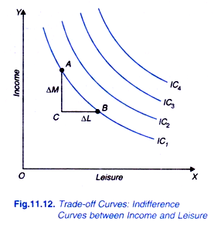](http://cdn.economicsdiscussion.net/wp-content/uploads/2014/06/image111.png)[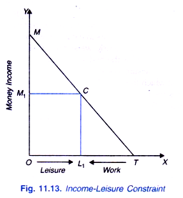](http://cdn.economicsdiscussion.net/wp-content/uploads/2014/06/image112.png)**

Indifference curves between income and leisure are also called trade-off curves as more of income would mean less of leisure time. The actual choice of income and leisure by an individual would also depend upon the wage rate per hour of work. Note that wage rate is the opportunity cost of leisure. That is, to increase leisure by one hour, an individual has to give up the opportunity of earning income (equal to wage per hour) which he can earn by doing work for an hour. This leads us to income-leisure constraint which together with the indifference map between income and leisure would determine the equilibrium.

The maximum amount of time available per day for the individual is 24 hours. Thus, the maximum amount of leisure time that an individual can enjoy per day equals 24 hours. In order to earn income he will devote some of his time to do work.

In Figure 11.13 leisure is measured in the rightward direction along the horizontal axis and the maximum leisure time is OT (equal to 24 hours). If the individual can work for all the 24 hours in a day, he would earn income equal to OM. Income OM equals OT multiplied by the hourly wage rate (OM = OT.w) where w is the wage rate.

The straight line MT is the budget constraint or income-leisure constraint which shows the various combinations of income and leisure among which the individual will have to make a choice. If a person chooses combination C, it means that he has OL1 amount of leisure time and OM1 amount of income. He has earned OM1 amount of income by working TL1 hours of work. Choice of other points on income-leisure line MT will show different amounts of leisure, income and work.

Income OM = OT. W . The slope of the income-leisure curve OM/OT equals the wage rate.

**[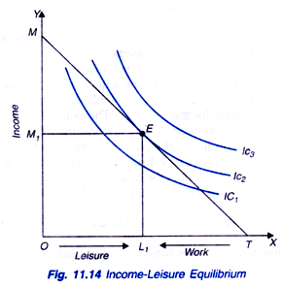](http://cdn.economicsdiscussion.net/wp-content/uploads/2014/06/image113.png)**

**Income-Leisure Equilibrium:**

Our model is based on two assumptions.

1. He is free to work as many hours per day as he likes.

2. Wage rate is the same irrespective of the number of hours he chooses to work.

Figure 11.14 shows income-leisure equilibrium of the individual. With the given wage rate, the individual will choose a combination of income and leisure that maximizes his satisfaction. In Figure 11.14 income- leisure line MT is tangent to the indifference curve IC2 at point E. At equilibrium individual chooses OL1 of leisure and OM1 of income. In this equilibrium position the individual works for TL1 hours per day (TL1 = OT- OL1). Thus, he has worked for TL1, hours to earn OM1 amount of income.

**NEED FOR HIGHER OVERTIME WAGE**

If the firm wants workers to work overtime, then they must pay higher wages.

With the given wage rate and given trade-off between income and leisure the individual chooses to work for TL1 hours per day. To do overtime work, he will have to sacrifice more leisure-time and therefore to provide him incentive to give up more leisure and thus to work for more hours it is required to pay him higher wage rate.

This is shown in Figure 11.15 where at the equilibrium point E a steeper leisure- income line EK is drawn. TL1 is the hours worked at the wage rate w represented by the slope of the income-leisure line MT. If the higher overtime wage rate w’ represented by the line EK is fixed, the individual is in equilibrium at point H on indifference curve IC2 where he chooses to have OL2 leisure time and OM2 amount of income. Thus, he has sacrificed L1L2 more leisure to do overtime work and earns M1M2 more income than before. He now works for TL2 hours per day, Further, he is better off than before as he is now at higher indifference curve IC2.

**[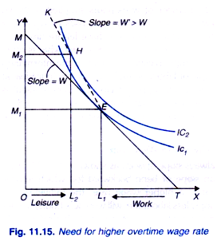](http://cdn.economicsdiscussion.net/wp-content/uploads/2014/06/image114.png)**

**DERIVATION OF Supply of Labour:**

Supply curve of labour shows amount individual will work in response to changes in the wage rate. The derivation of supply curve of labour is shown in Figure 11.16. In panel (a) of this figure it will be seen that at the wage rate w0 , the wage line or income-leisure line is TM0 and the individual is in equilibrium at point Q where he chooses OL0 leisure time and works for TL0 hours.

That is, at wage rate w0 he supplies TL0 amount of labour. This is shown  in diag (b) of Figure 11.16. Now, when the wage rate rises to w1, wage line or income-leisure line shifts to TM1 , the individual reduces his leisure to OL1 and supplies TL1 hours of work; L1L0 more than before (see Panel (a) in Figure 11.16). Thus, L1 number of work-hours supplied is shown against w1 in (b) of Figure 11.16.

When the wage rate rises to W2, income-leisure line shifts to TM2 the individual chooses to have leisure time OL2 and supplies TL2 work-hours. In panel (a) on joining points Q, R and S we get **wage-offer curve**. In panel (b), the supply of labour is derived at different wage rates which is upward sloping showing that individual will work more with the rise in wage rate.

ADVERTISEMENTS:

**[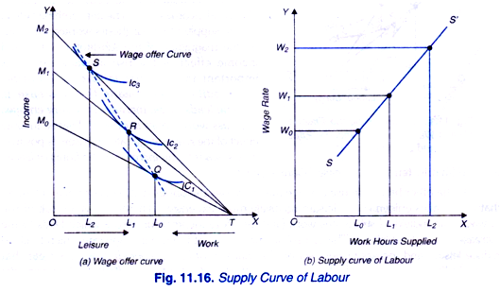](http://cdn.economicsdiscussion.net/wp-content/uploads/2014/06/image115.png)**

**Income Effect and Substitution Effect of the Change in Wage Rate:** The supply curve of labour does not always slope upward as shown in Fig. 11.16. It can slope or bend backward too which implies that at a higher wage rate, the individual will supply less labour (i.e. will work less hours). This can be explained in terms of income effect and substitution effect of a change in wage rate.

A rise in wage rate has both the substitution effect and income effect. The net combined effect on the supply of labour depends on the magnitude of the substitution effect and income effect. leisure is regarded as a normal good which means that increase in income leads to the increase in leisure . That is, income effect of the rise in wage rate on leisure is positive, which means decrease in labour supply.

On the other hand, the rise in wage rate increases the opportunity cost or price of leisure, that is, it makes enjoyment of leisure more expensive. Therefore, with rise in wage rate individual substitutes work for leisure which leads to the increase in supply of labour. This is a substitution effect of the rise in wage rate which tends to reduce leisure and increase labour supply .

**Income effect** of the rise in wage rate tends to reduce supply of labour, **substitution effect** tends to increase supply of labour. If the income effect is stronger than the substitution effect, the net combined effect of rise in wage rate will be to reduce labour supply. On the other hand, if substitution effect is relatively larger than the income effect, the rise on wage rate will increase labour supply.

This is shown in Fig 11.17. In this figure we measure money income on the Y- axis and leisure (reading from left to right) and labour supply (reading from right to left) on the X-axis. Suppose to begin with the wage rate is W0 .

Thus, with wage rate W0 the individual is in equilibrium when he enjoys OL0 leisure and therefore he is supplying TL0 work hours of labour.

Now suppose that wage rate rises to w1 with the result that income- leisure constraint line rotates to TM1. Now, with TM1 as new income-leisure constraint line, the individual is in equilibrium at point H at which he supplies TL1 hours of labour which are less than TL0.

**[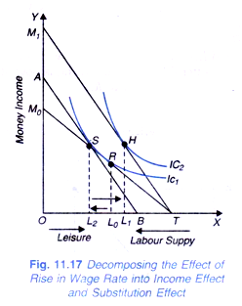](http://cdn.economicsdiscussion.net/wp-content/uploads/2014/06/image116.png)**

Thus, with the rise in wage rate, supply of labour has decreased by L0L1. Now we break up this wage effect into income ad substitution effect - We draw AB which is tangent to original indifference curve IC1 at point S to show the substitution effect. With change in wage rate from w0 to w1,leisure becomes relatively more expensive, he substitutes work L0L2 for leisure. This is substitution effect that tends to increase labour supply by L0L2,

The final equilibrium point is H. Movement from point S to H represents the **income effect** of the rise in wage rate and as a result labour supply decrease by L2L1.

Thus, while income effect of the increase in wage rate causes decrease in labour supply by L2L1 the substitution effect causes increase in labour supply by L2L1. It will be seen from Fig. 11.17 that in this case income effect is stronger than substitution effect so that the net result is reduction in labour supply by L0L1 work-hours and therefore in this case labour supply curve bends backward. Now, if substitution effect had been larger than income effect, work-hours supplied would have increased as a result of rise in wage rate and labour supply curve would slope upward.

**Backward Bending Supply Curve of Labour:**

It has been empirically observed that when the wage rate is small, substitution effect is larger than the income effect so that the net effect of rise in wage rate will be to increase the supply of labour.

But when individual is already supplying a large amount of labour and is earning sufficient income, further increases in wage rate may induce the individual to demand more leisure so that income effect may outweigh the substitution effect at higher wage rates. So supply of labour will fall

This means up to a point substitution effect is stronger than income effect so that labour supply curve slopes upward, but beyond that at higher wage rates, supply curve of labour bends backward.

This is shown in Fig 11.18 where in panel (a) wage offer curve is shown, and in panel (b) supply curve of is drawn corresponding to leisure-work equilibrium in panel (a). At wage rate w0 , L0 amount of work-hours (labour) are supplied. This is plotted against the wage rate w0 in panel (b) of Fig. 11.18. When the wage rate rise to w1 budget constraint becomes TM1 in panel (a) of Fig. 11.18 and greater amount of labour L1 is supplied.

Amount of labour L1 is directly plotted against higher wage rate w1 in panel (b) of Fig. 11.18. With the further increase in wage rate to w2, the income-leisure constraint rotates to TM2 and the individual is in equilibrium when he supplies L2 work-hours which are smaller than L1. Thus, with the rise in wage rate above w1, labour supply decreases. In other words, up to wage rate w1, labour supply curve slopes upward and beyond that it starts bending backward. This is quite evident from panel (b) of Fig. 11.18.**[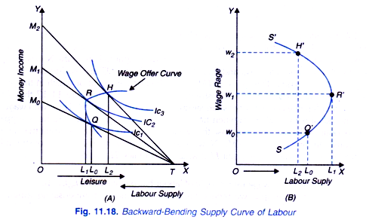](http://cdn.economicsdiscussion.net/wp-content/uploads/2014/06/image117.png)**